Activity 3.2.6 Beam Design

Introduction
Beam design is based on four important considerations: bending moment, shear, deflection, and cost. Once the design loads have been determined and the beam has been analyzed to determine the resulting internal shear forces and bending moments imposed, a structural engineer can select a cost-effective beam design that will provide sufficient shear and bending strength and adequate stiffness to limit deflection to acceptable limits.

Beam design methods are dictated by building codes and standards and require the inclusion of a factor of safety. Therefore, the beam design selected must possess more strength than required to resist the imposed loads.

In this activity you will design floor framing (beams and girders) for a hotel.

Procedure
The Partial Second Floor Framing Plan for a new hotel is given below. The second floor will be used for conference space. Design the following floor framing members for the hotel structure.
- Interior beam
- Exterior beam
- Girder on column line 3
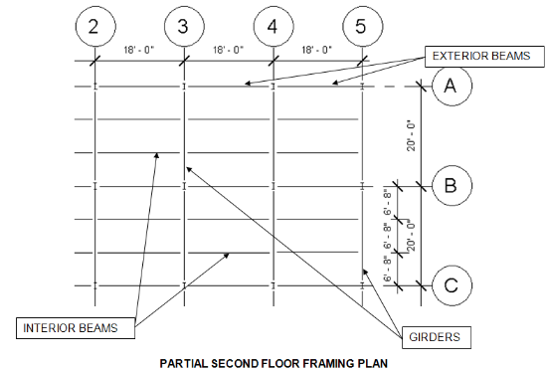
- Girder on column line 5

Criteria
The following data is to be used for design of the floor framing:
- Dead load = 50 psf
- Assume the weight of the floor beams and girders are included in the dead load
- Floor live load = 100 psf (Hotels—Public space per IBC table 1607.1)
- F_{y} = 50,000 psi
- The floor will support a plaster ceiling
Note: E = 29,000,000 psi for structural steel

4

Interior Beam

- Include the loading and beam diagrams.

- Calculate the end reaction and maximum moment
$$M_{max}=\frac{{WL}^{2}}{8}=\frac{1,000 lb. ×{18}^{2}}{8}$$
$$M_{max}=40,500\frac{ft}{lb}.$$

$$R_{a}=R_{b}=\frac{WL}{2}=\frac{1,000\frac{lb}{ft} × 18}{2}$$
$$R_{a}=R_{b}=9,000 lb.$$

5

- Calculate the required nominal moment.
$$M_{n}>M_{a}×Ω_{b}$$
$$M_{n}>40,500×1.67$$
$$M_{n}>67,635\frac{ft}{lb}.$$

- Determine the required plastic section modulus and select an efficient wide flange.
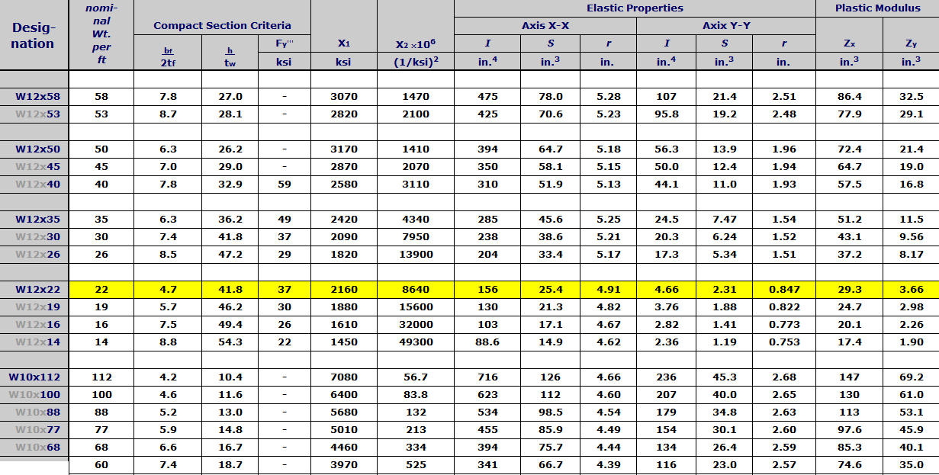
$$M_{n}=F_{y}×Z_{x}$$
$$Z_{x}≥\frac{M_{n}}{F_{y}}$$
$$Z_{x}≥\frac{811,620}{50,000}$$
$$Z_{x}≥16.2324 {in.}^{3}$$

- Check the shear strength.
$$V_{n}=V_{a}×Ω_{v}$$
$$V_{n}=9,000×1.5=13,500 lbs.$$
$$A_{w}=2.382$$
$$V_{n W12x14}=71,460$$

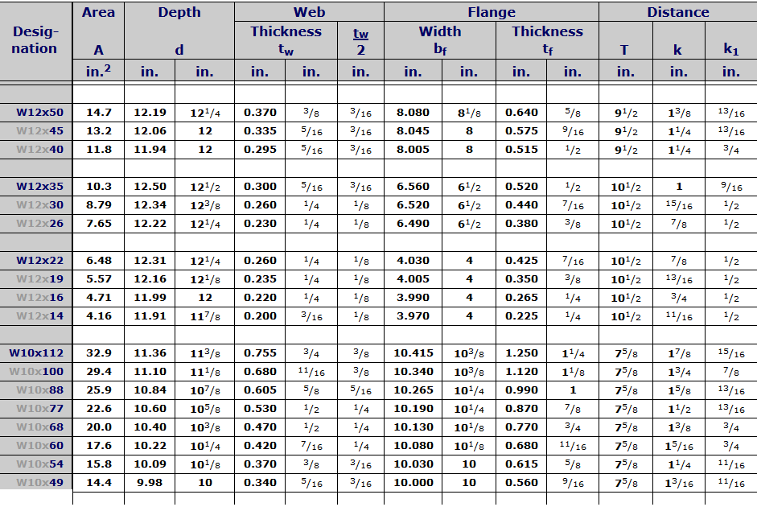

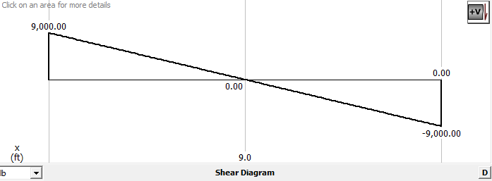

- Calculate deflection limits.
$$LL+DL=0.9"$$
$$LL=0.6"$$

- Calculate actual deflections.
$$∆MAX=0.919 inches$$
$$∆MAX=0.79 inches$$

- Select a final design.
We would pick the W12x16 beam because the W12x14 beam would not work with safety requirements.
6

